CYBER SECURITY ASSIGNMENT (SEZG681)

RESEARCH PAPER

SUBMITTED BY: SUPRIYA P (2023TM93755)

Application of Cybersecurity Features in Drone Operations Against Terrorism

# Introduction

Technology keeps moving forward and still impacts our response to surveillance and defense in the digital era. Drones, also known as Unmanned Aerial Vehicle (UAV), are some of the most key inventions. Drones started out as a form of surveillance asset but continue to develop and perform a variety of functions in military and civilian contexts. They are used for anything from intelligence collection and targeted attacks to environmental monitoring and catastrophe relief. But their growing popularity also brings with it new difficulties, especially when you consider how easily they may be taken advantage of. Because of its dual purpose, drone cybersecurity must be carefully considered, particularly in relation to counterterrorism.

It is impossible to exaggerate the danger that unprotected drone systems offer. Using cyberattacks, attackers can redirect drones used by defense organizations. Now terrorist groups can use existing advanced technologies that employ drones to attack, to create a targeted and deadly attack, rather than just utilizing elementary military means. The defenses against these groupings need to change along with them. This leads us to a crucial query: to what extent are the drones we depend on safe? Physical control is only one aspect of the problem; another is protecting data, communications, and software systems from online attacks.

Since drones started to be used extensively in military operations in the early 2000s, this problem has existed. They were first managed through secure satellite communications, but their popularity quickly expanded, and they found new uses in the business world. However, cybersecurity was frequently overlooked in the fervor surrounding drone deployment. The weaknesses were exposed over time. Cybercriminals and hostile entities found it easy to target drones that were using open-source software, unencrypted channels, or simple Wi-Fi protocols. The international defense community became alarmed when reports of GPS spoofing, drone hijacking, and data breaches started to surface.

This paper seeks to demonstrate the importance of implementing robust cybersecurity mechanisms in drone operations, specifically to counter the misuse of UAVs by terrorist organizations. Through an in-depth examination of past incidents, current vulnerabilities, and potential technological and strategic solutions, this study will provide a roadmap for developing resilient drone infrastructure capable of withstanding cyber threats.

# Extent and Impact of the Problem

The range of the issue of drone cybersecurity, as well as its seriousness and urgency have changed, too. An easily available drone can disrupt daily living; an example being the situation concerning Gatwick in 2018 and the resulting cancellation of more than 1000 flights. The disruption that occurred at Gatwick is a demonstration of how easily drone systems can disrupt and challenge key infrastructures, and this case had no real connection to terrorism either. A drone attack, as well as missile systems targeting oil infrastructure in Abu Dhabi, is a more worrying example in 2022.

The concern is compounded when considering modern drone technologies. Drones are capable of increasingly autonomous operations, which require little human input, using these technologies - high-definition cameras, GPS-based navigation, autonomous flight modes, and now even facial recognition. However, these technologies also make them vulnerable. Drones and their operators typically depend on protocols that can be compromised by man-in-the-middle attacks. Attackers can inject or intercept malicious commands without encryption. Other drone software is susceptible to malware, or modifications, because it is lacking basic hardening for integrity.

These vulnerabilities can be assessed against various groups of actors. With regards to military actors, these military surveillance drones can either leak data or alter data. Energy infrastructures are open to sabotage and reconnaissance. Civilian groups are at risk as drones can provide info on movements and even drop payloads on crowded events. Evidence suggests that it harms the psyche, leading to instability and fear.

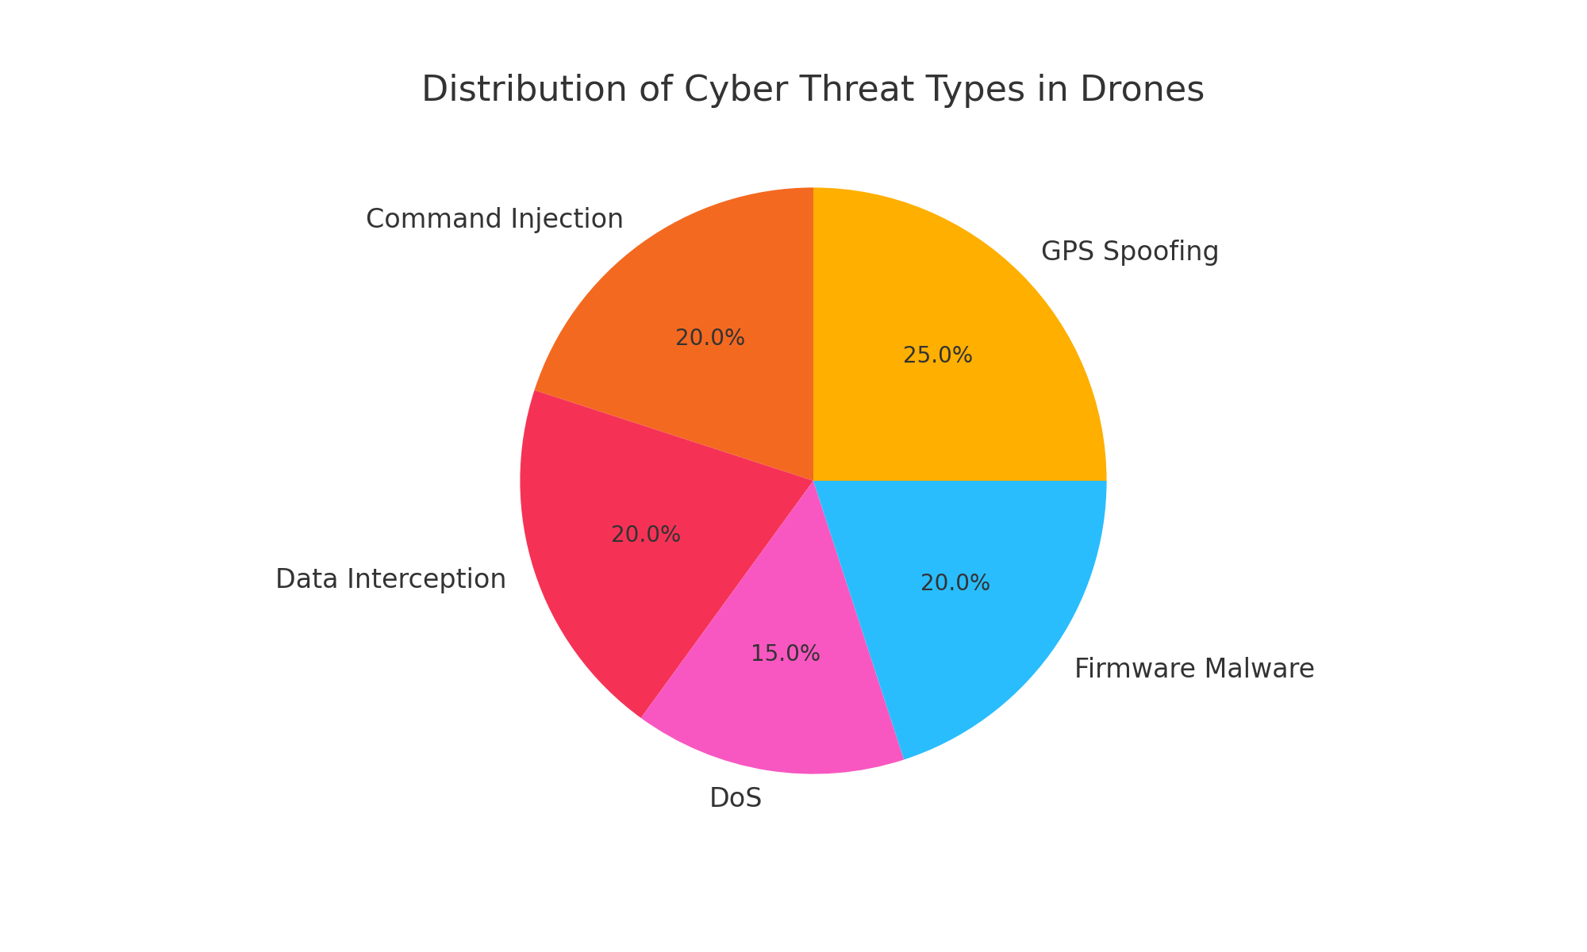

# Cause and Effect Analysis

Drones have been vulnerable to cyberattacks due to flaws in autonomous navigation and communication protocols, jeopardizing mission integrity and data. **These vulnerabilities provide attackers the potential to disrupt or hijack drone operations entirely.**  
**If these vulnerabilities are not resolved, terrorist organizations could eventually use drones for attacks, smuggling, and surveillance. The need for strong security systems is emphasized when one considers that even commercially available drones have been adapted to illegitimate usage.**

# Case Studies on Cyber Crimes Involving Drones

Iran Incident 2011: One of the most highly publicized incidents was in 2011 when Iran claimed it hacked a US RQ-170 Sentinel drone by spoofing the U.S. GPS signal. This claim has not been confirmed by the U.S. but many scholars and experts believe there was some level of cyber manipulation. This incident underscores that advanced drones can also be hacked.

Gatwick Airport Disruption 2018: Between December 19 and December 21, 2018, drone sightings near Gatwick Airport caused about 1,000 flight cancellations, affecting nearly 140,000 passengers. This event demonstrated the disruptive capabilities of drones and the complexities that such disruption can pose.

Abu Dhabi Attack 2022: In January 2022, the Houthi movement carried out a coordinated drone and missile attack on fuel trucks and airport infrastructure in Abu Dhabi, which resulted in civilian casualties. This represented a new level of threat as the drone might be suggestive of a new type of terrorist activity.

# ****Cybersecurity Landscape and Threats in Drone Operations****

## ****Vulnerabilities in Drone Systems****

### Drones are vulnerable to several cyber threats because of wireless communication, GPS navigation, and onboard sensors. Some key vulnerabilities include:

### GPS spoofing: Changing the GPS signals received by the drone to mislead its navigation.

### Signal jamming: Interfering with the communication from the drone back to its control station.

### Unauthorized access: Using easily compromised authentication methods to gain control.

### Data interception: Eavesdropping on unencrypted data being communicated.

## ****Threat Actors****

### Threat actors leveraging drone vulnerabilities include:

* Terrorist organizations: Activating drones for observation, weapon delivery, or propaganda.
* State-Sponsored hackers: Engaging in attacking sensitive infrastructure.
* Hacktivists: Making attacks to advance ideological goals.

# Solutions and Security Mechanisms

To ensure that the drone operations are secure and protected, a variety of security techniques will need to be applied. Some of these would include E2EE (end-to-end encryption) of the communication pathways, AI-based threat detection systems integrated into the drone, and SIEM (Security Information and Event Management) monitoring of the Drone System in real-time. Other technologies include IDS (Intrusion Detection Systems), Anti-Spoofing modules, etc. that would also augment resilience.

Some of the advanced methods might include:

• blockchain based command authorization

• secure boot procedures

• firmware integrity monitoring

**AI-based algorithms** for anomaly detection will also assist with proactive mitigation of emerging threats.

**Security Mechanisms for Drone Systems**

Encryption Technologies

E2EE (end-to-end encryption) using AES-256 (symmetric) and RSA (asymmetric) public/private key pairs will ensure that bidirectional information flow to/from UAVs and control stations are secure. Quantum-resistant algorithms are currently under analysis with next-generation drones.

Authentication Procedures

• Public-key infrastructure (PKI)

• Two-factor Authentication / Multi-Factor Authentication (2FA / MFA)

• Hardware Security Modules (HSM)

Intrusion Detection Systems (IDS) Real-time detection of command injection, or user access can be accomplished with Anomaly-based and signature-based IDS.

Secure Boot and Firmware Validations robustly limits the potential of executing malware in compromised firmware by validating the integrity of code on startup.

The use of blockchain to preserve log integrity and mission data can mitigate the tampering and assist in auditing and provenance combination with decentralized storage assets.

# Strategic Defense Frameworks

**National and International Cybersecurity Standards**

* ISO/IEC 27001
* NIST Cybersecurity Framework
* EU Cybersecurity Act (for cross-border data flows and AI-enabled drones)

**Defense-in-Depth Architecture** A multi-layered approach involving:

* Network segmentation
* Firewall rules
* Endpoint protection on GCS
* Redundancy and failover systems

**Red Teaming and Penetration Testing** Simulated attacks on UAV systems help uncover security flaws before adversaries can exploit them.

**Secure Software Development Lifecycle (SSDLC)** Integrating security throughout development using threat modeling, secure coding practices, and continuous testing.

# Policy recommendations

**UAV Cybersecurity Legislation** Enforce laws mandating minimum cybersecurity requirements for commercial and governmental drones.

**Public-Private Partnerships (PPP)** Foster collaboration between defense contractors, tech firms, and academia to drive innovation and threat intelligence sharing.

**Drone Traffic Management Systems (DTMS)** Integrate cybersecurity into DTMS to mitigate the risk of rogue drones.

**Mandatory Cyber Certification** Similar to airworthiness certification, cyber-certification for UAVs should be mandatory.

# Challenges in securing UAVs against Terrorists

* **Resource Constraints:** Lightweight drones have limited processing power for strong encryption.
* **Legacy Systems:** Older drones lack modern security features.
* **Rapid Technological Evolution:** Security measures struggle to keep up.
* **Global Supply Chains:** Risks of embedded hardware backdoors.

# Future Directions and Technologies

* **AI-Driven Threat Detection** Machine learning algorithms can predict anomalies in flight behavior or system performance.
* **Quantum-Resistant Cryptography** Preparation for the post-quantum era ensures that drone communications remain secure.
* **Bio-Authentication for GCS** Adding biometric security to human operators.
* **Digital Twins** Replicating UAV systems virtually allows simulation of attack scenarios and defense effectiveness.

# Conclusion

The threat posed by unsecured drone operations is not hypothetical: it has been evidenced through real-world examples. When compromised drones present a significant danger instead of a technological asset.

Implementing and enforcing strong cybersecurity policies, operationalizing AI-enabled protection systems, and building partnerships on the international stage will enable drone systems to be re-established as secure, reliable, and trustworthy assets in the global effort to combat terrorism.

# References

1. M. R. Endsley, “The Role of Situation Awareness in UAV Operation,” Journal of Cognitive Engineering and Decision Making, 2020.

2. U.S. Department of Homeland Security, "Threats of Unmanned Aerial Systems (UAS) to Critical Infrastructure," 2021.

3. J. Peterson et al., “Cybersecurity Vulnerabilities in Unmanned Aerial Vehicles,” IEEE Access, vol. 8, pp. 153456–153469, 2020.

4. B. Kumar and S. Sharma, “Drone Security: Issues, Challenges and Solutions,” Springer Nature, 2021.

5. White Paper by NATO Science and Technology Organization, “Countering Unmanned Aerial Systems,” 2022.